Integrate the Jira account:
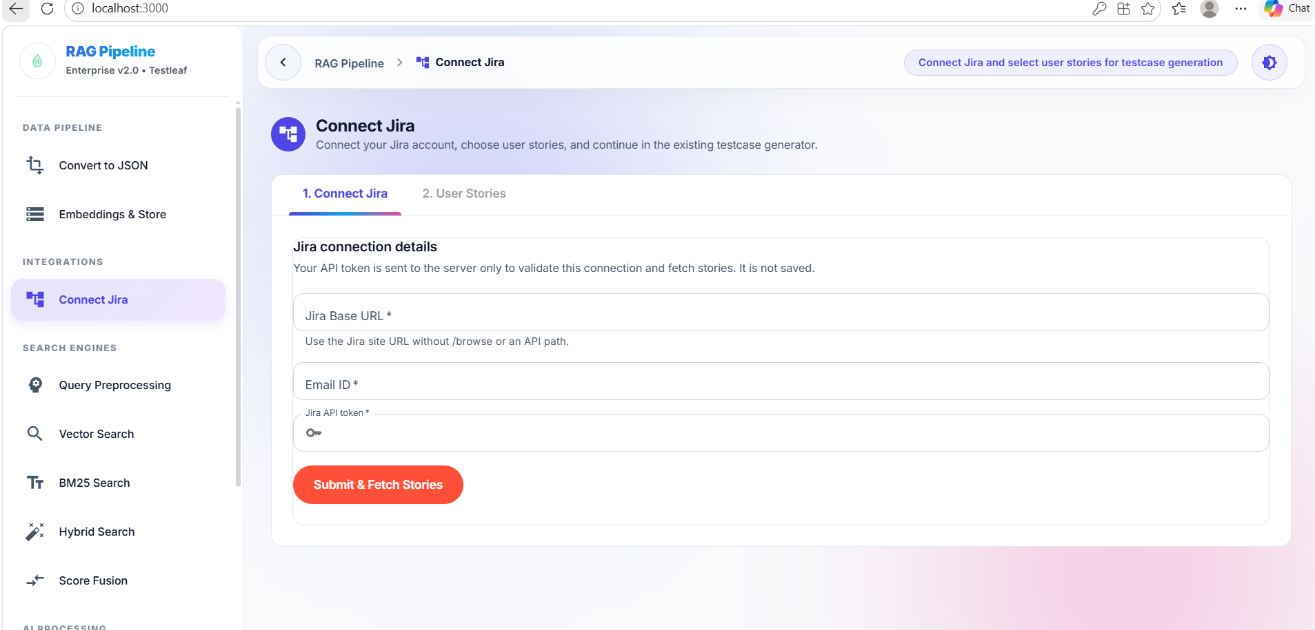
- Enter the information and connect with jira tool
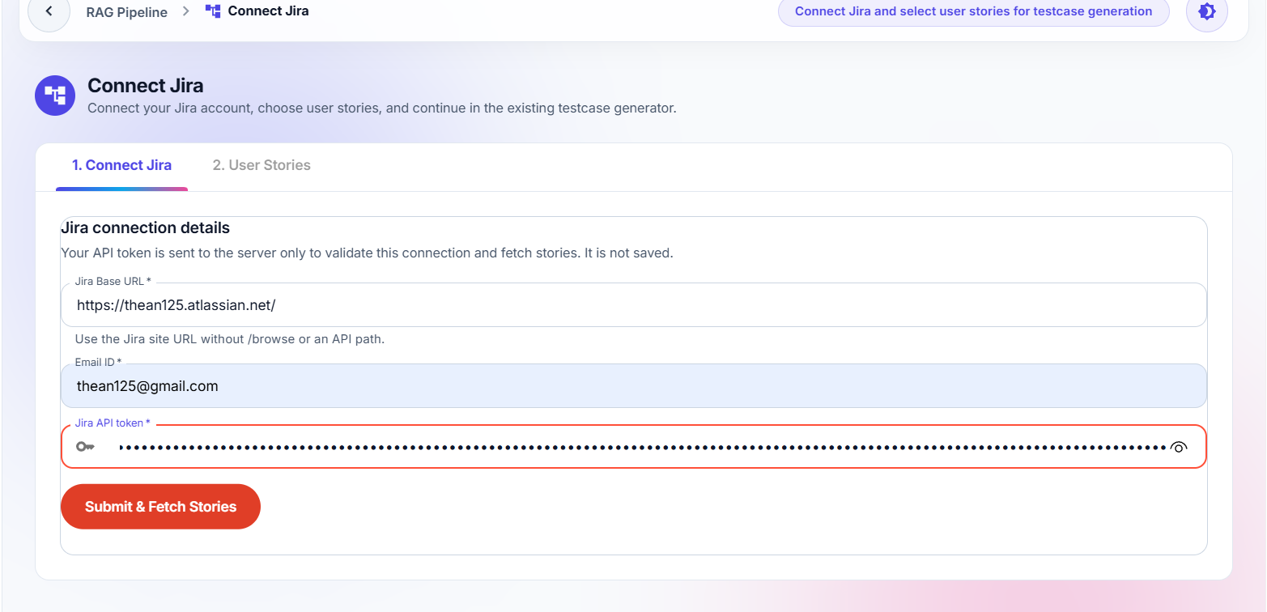
- Connect and fetch the user stories
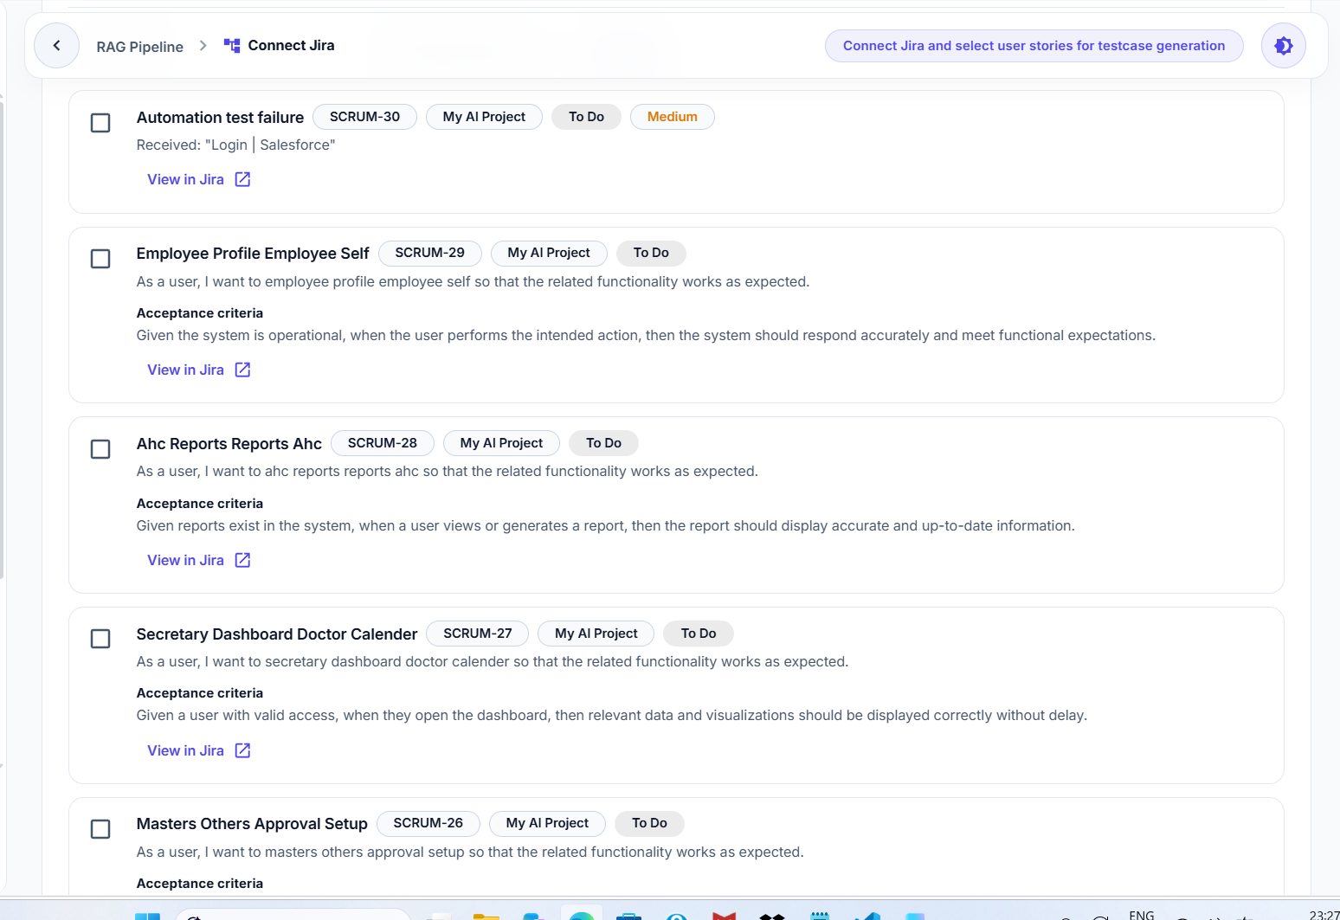
- Choose the user stories and click the testcase generate button
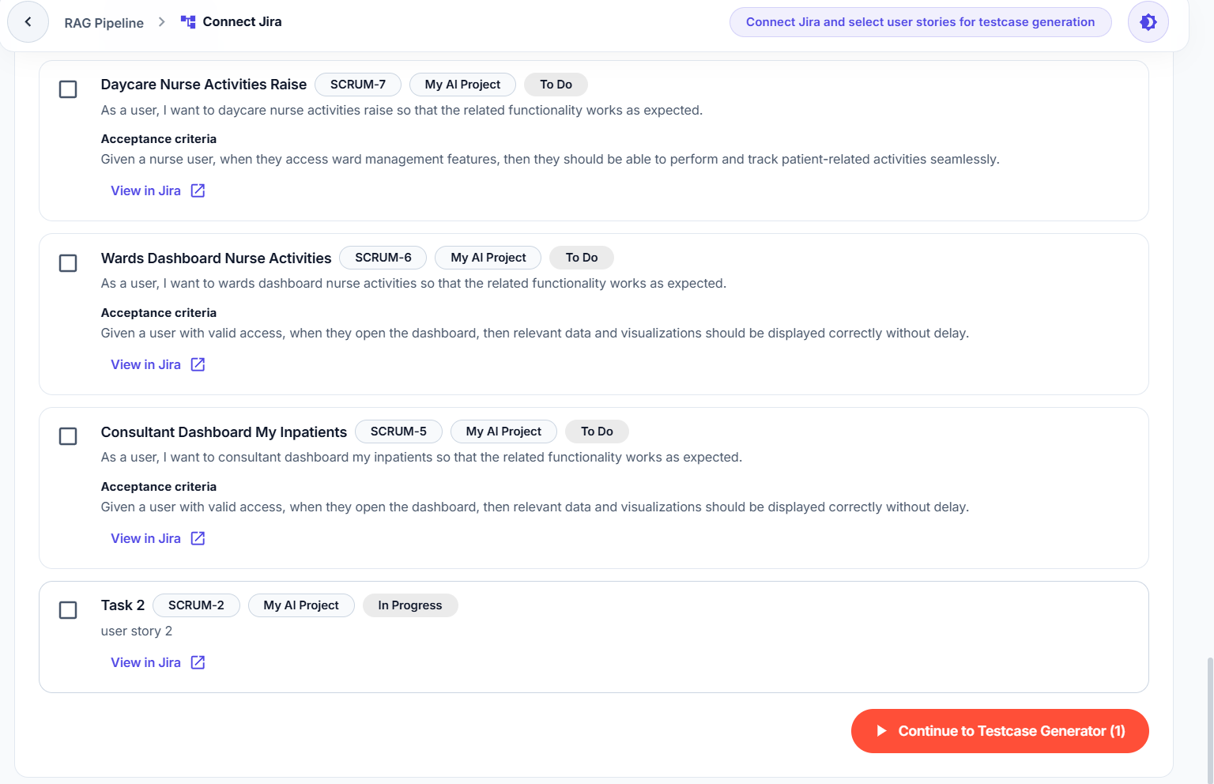
- Once click the button, it fetch to the existing testcase generate functionality
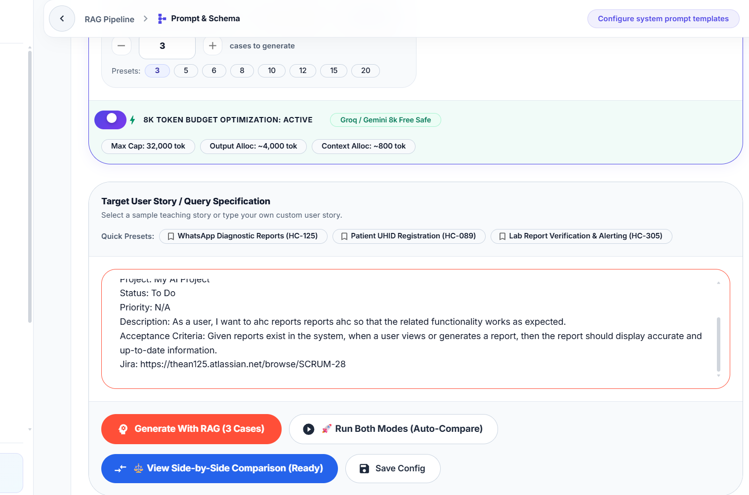
- Then generate with RAG or choose any option based on that testcase has been generated
